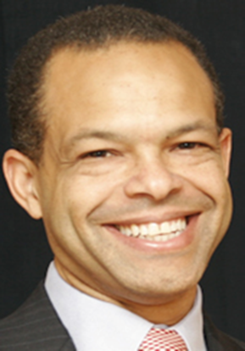

Biography of Malcolm Augustine
State Senator

Senator Malcolm Augustine was born in Lafayette, Louisiana on March 10, 1969. He is a graduate of Pittsford Mendon High School, and Harvard College, (A.B. Government 1991). He has served as Operations Support Analyst for the Federal Reserve Bank of New York, 1991-1993; Co-Founder and Managing Director for Alliance Telecom, 1993-1995; Executive Vice President of Customer Relations for Eltrex Industries, 1996-2003; Principal at Glyde Communications, 2002-present; and Director of Business at Intra-Mail Network.
In 2018, Senator Augustine was elected to represent Prince George’s County District 47 in the Maryland State Senate, where he has been a member since January 2019. Current assignments Senator Augustine is working on include (2019) Senate Finance; (2019) Senate Chair-Joint Committee on the Management of Public Funds; (2019) Energy and Public Utilities Subcommittee of the Finance; (2019) Joint Committee on Administrative, Executive and Legislative Review; (2019) Joint Audit and Evaluation Committee; (2020) Joint Committee on Behavioral Health and Opioid Use Disorders; (2020) Joint Electric Universal Service Program (EUSP) Workgroup; (2019) Joint Committee on Federal Relations; is a member of the (2019) Legislative Black Caucus of Maryland; and (2019) associate member of the Maryland Legislative Latino Caucus. Senator Augustine is a life member of Kappa Alpha Psi.
Public Service includes - Task Force to Study Transportation Access (2019), Prince George’s County Workgroup on Alcohol Outlet Density Zones (2019), Virginia I. Jones Alzheimer’s Disease and related Disorders Council (2019), Board of Directors for the Washington Area Metropolitan Transit Authority (WMATA) (2019), Suburban Transit Commission (2015-2018), Prince Georges County Central Committee (2015-2018), and Executive Board Progressive Maryland (2014).
Senator Augustine played an important role in securing dedicated funding for Metro infrastructure, and brought 800 jobs and a new 200,000- ft- tall facility to New Carrollton Metro Station. He previously chaired the Prince George’s County Cable Commission and oversaw Verizon and Comcast franchise agreements. While serving as a member of the WMATA Board representing Prince George’s County, he unwaveringly supported Metro employees.
Malcolm attends Saint Ambrose Church in Cheverly, MD where he serves as an usher, and is a member of the school advisory board.
Senator Malcolm Augustine resides in Cheverly, MD with his wife Lauren and two children. He has been a resident of Prince George’s County for 20 years.

